Business Problem: Recommend a best book based on the author, publisher and ratings.

**EDA**

DataSet : Books

Install fallowing packages,

* recommenderlab
* reshape2

Choose the file (Books)

book_data <- read.csv(file.choose())

View(book_data)

There are 5000 observations with 5 variables.

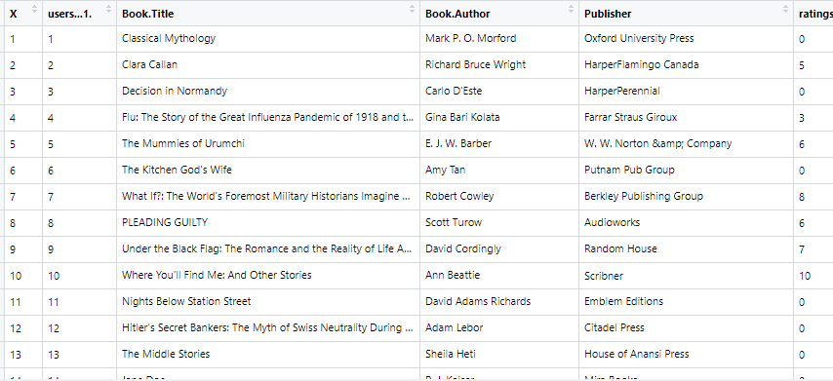

# Geting column names

names(book_data)

[1] "users...1." "Book.Title" "Book.Author"

[4] "Publisher" "ratings...3.

Renaming the columns for readability,

# Renaming column names

names(book_data) <- c("Users", "Book_Title", "Book_Author", "Publisher", "Ratings")

as.factor(book_data$Users)

there are 5000 users rated 4839 unique books

# Structure of data

str(book_data)

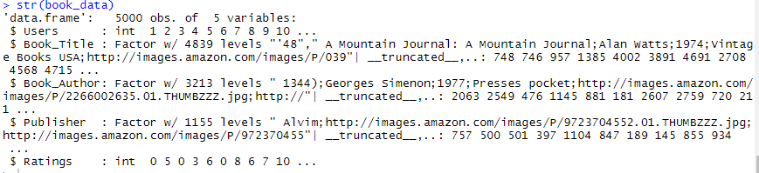

# Distrubution of Rating

hist(book_data$Ratings)

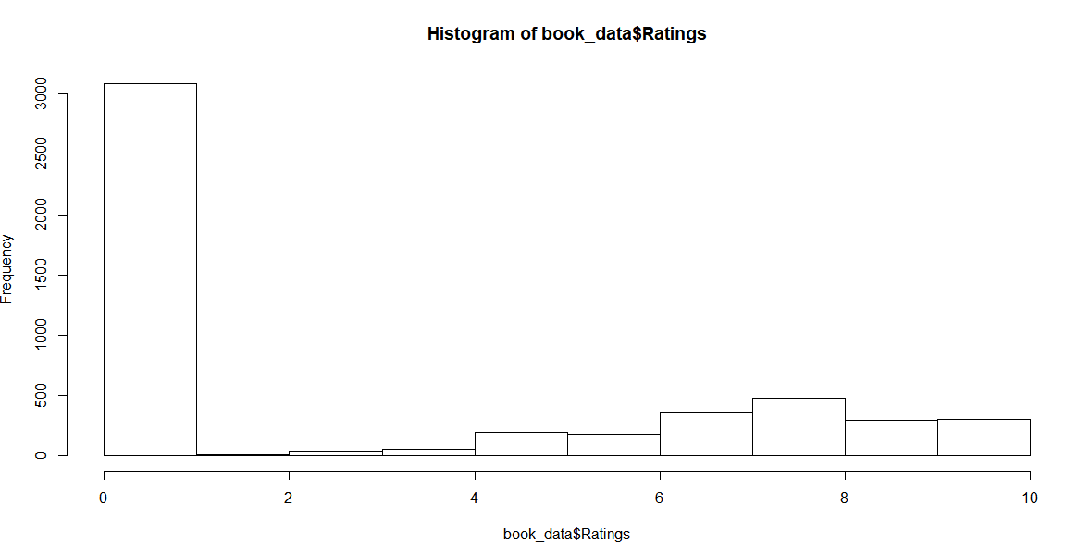

From the histogram we can observed right skewedness / positively skewed in the dataset.

# Building Recommendation Model

# Popularity based

book_popular_model <- Recommender(book_data_matrix, method = "POPULAR")

# Building Recomendation Model

# Popularity based

book_popular_model <- Recommender(book_data_matrix, method = "POPULAR")

# Predictions for two users

recommended_popular <- predict(book_popular_model, book_data_matrix[1456], n = 3)

book_popular <- as(recommended_popular, "list")

The user id 1456 is recommended by following 3 books,



###--------------------

# User Based Collaborative Filtering

book_uscf_model <- Recommender(book_data_matrix, method = "UBCF")

# Predictions for two users

recommended_ubcf <- predict(book_uscf_model, book_data_matrix[500:550], n=5)

book_uscf <- as(recommended_ubcf, "list")

###--------------------

# Item Based Collaborative Filtering

book_ibcf_model = Recommender(book_data_matrix, method = "IBCF")

# Predictions for two users

recommended_ibcf <- predict(book_ibcf_model, book_data_matrix[500:550], n = 1)

book_uscf <- as(recommended_ibcf, "list")

###--------------------

# SVD

book_svd_model = Recommender(movie_rate_data_matrix, method = "SVD")

# Predictions for two users

recommender_svd <- predict(book_svd_model, movie_rate_data_matrix[500:550], n=5)

book_svd <- as(recommender_svd, "list")

###--------------------